VILLA MARIN HOMEOWNER’S ASSOCIATION

INDEPENDENT AUDITOR'S REPORT AND CONTINUING CARE

RESERVE REPORT SCHEDULES
YEAR ENDED OCTOBER 31, 2025
VILLA MARIN HOMEOWNERS' ASSOCIATION
CONTENTS
YEAR ENDED OCTOBER 31, 2025

Page(s)
INDEPENDENT AUDITOR'S REPORT 1
CONTINUING CARE RESERVE REPORT SCHEDULES
Form 1-1 Resident Population 2
Form 1-2 Annual Provider Fee 2
Form 5-1 Long-Term Debt Incurred In A Prior Year 3
Form 5-2 Long-Term Debt Incurred During Fiscal Year 4
Form 5-3 Calculation Of Long-Term Debt Reserve Amount 5
Form 54 Calculation Of Net Operating Expenses 6
Form 5-5 Annual Reserve Certification 7
Villa Marin, Department Of Social Services, Detail Of Reserves-Operating,
Health & Safety Code Section 1790(a)(2), Attachment To Form 5-5 8
Villa Marin, Department Of Social Services, Detail Of Reserves-Property,
Health & Safety Code Section 1790(a)(2) & (3), Attachment To Form 5-5 9
NOTES TO CONTINUING CARE RESERVE REPORT SCHEDULES

LEVY, ERLANGER & COMPANY LLP
100 Montgomery Street, Suite 715 San Francisco, CA 94104

INDEPENDENT AUDITOR'S REPORT
Board Of Directors

Villa Marin Homeowners' Association
San Rafael, California
We have audited the accompanying continuing care reserve report schedules, Forms 1-1 through 5-5 (including Form 5-5 Attachments) (the Schedules) of Villa Marin Homeowners' Association (the Association) as of October 31, 2025. These Schedules are the responsibility of the Association's management. Our responsibility is to express an opinion on these Schedules based on our audit.
We conducted our audit in accordance with auditing standards generally accepted in the United States of America. Those standards require that we plan and perform the audit to obtain reasonable assurance about whether the Schedules are free of material misstatement. An audit includes examining, on a test basis, evidence supporting the amounts and disclosures in the Schedules. An audit also includes assessing the accounting principles used and significant estimates made by management, as well as evaluating the overall presentation of the Schedules. We believe that our audit provides a reasonable basis for our opinion.
The accompanying Schedules were prepared for the purpose of complying with California Health and Safety Code Section 1790(a) as described in Note 2, in accordance with the instructions provided by the State of California Department of Social Services and are not intended to be a complete presentation of the Association's assets, liabilities, revenues and expenses.
In our opinion, the Schedules referred to above present fairly, in all material respects, the liquid reserve requirements of Villa Marin Homeowners' Association as of October 31 , 2025 in conformity with accounting principles generally accepted in the United States of America and the report preparation provision of California Health and Safety Code Section 1790(a).
This report is intended solely for the use of the Association and for filing with the California Department of Social Services and is not intended to be and should not be used by anyone other than these specified parties.

 I-LP
February 13, 2026
1

FORM 1-1

RESIDENT POPULATION
 | Number at beginning of fiscal year
[2] | Number at end of fiscal year
 | Total Lines I and 2 | 517


 Continuing Care Residents TOTAL
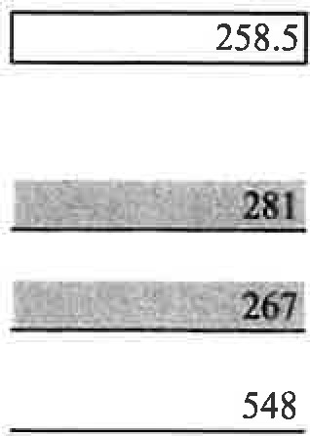
Multiply Line 3 by ".50" and enter result on Line 5.
x
.50
Mean number of continuing care residents
All Residents
- Number at beginning of fiscal year
- Number at' end of fiscal year
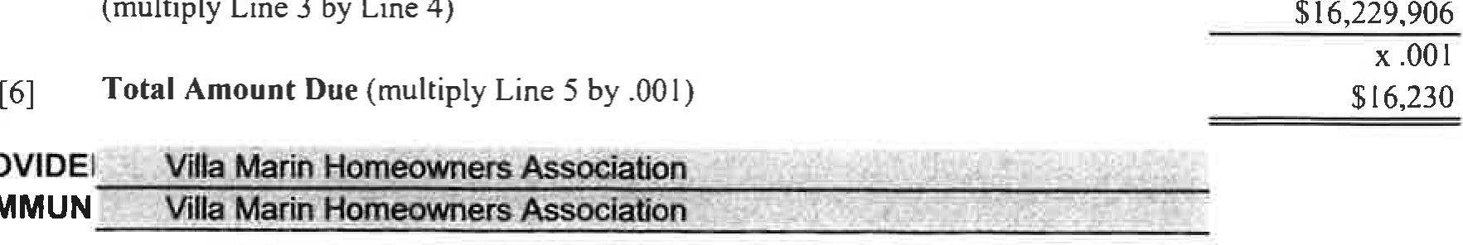
Total Lines 6 and 7
(multiply
Line
3
by
Line
4)
PROVIDEI
COMMUN
[9] Multiply Line 8 by ".50" and enter result on Line 10. | x .50
[10] Mean number of all residents 274
0.94
Divide the mean number of continuing care residents (Line 5) by the mean number of all residents (Line 10) and enter the result (round to two decimal places).
FORM 1-2 ANNUAL PROVIDER FEE
Total Operating Expenses (including depreciation and debt service - interest only)
[3] | Subtract Line 2 from Line I and enter result.
[4] | Percentage allocated to continuing care residents (Forrn I-I, Line I l) | 94%

[2] Subtotal (add Line la and 1b) $124,785
[5] Total Operating Expense for Continuing Care Residents
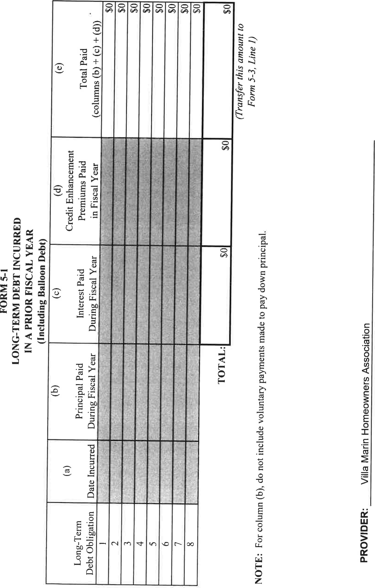
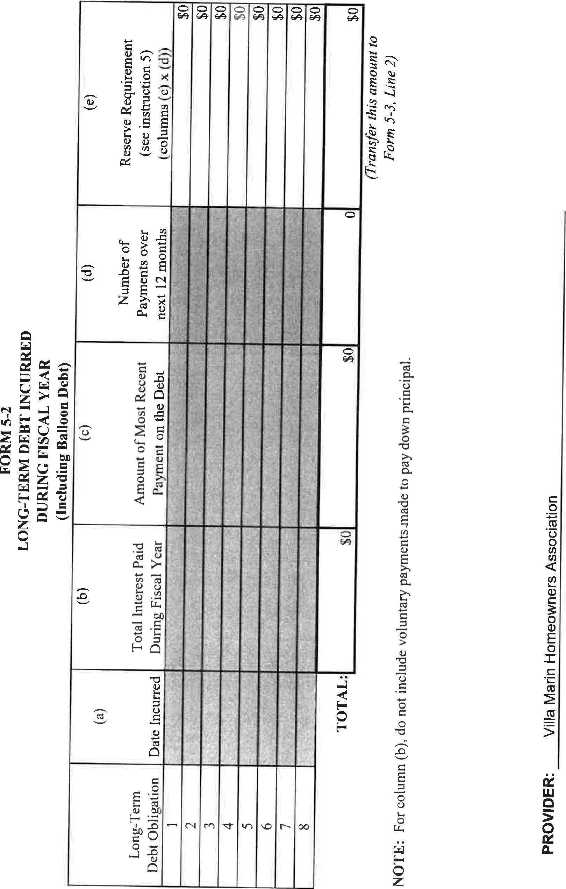
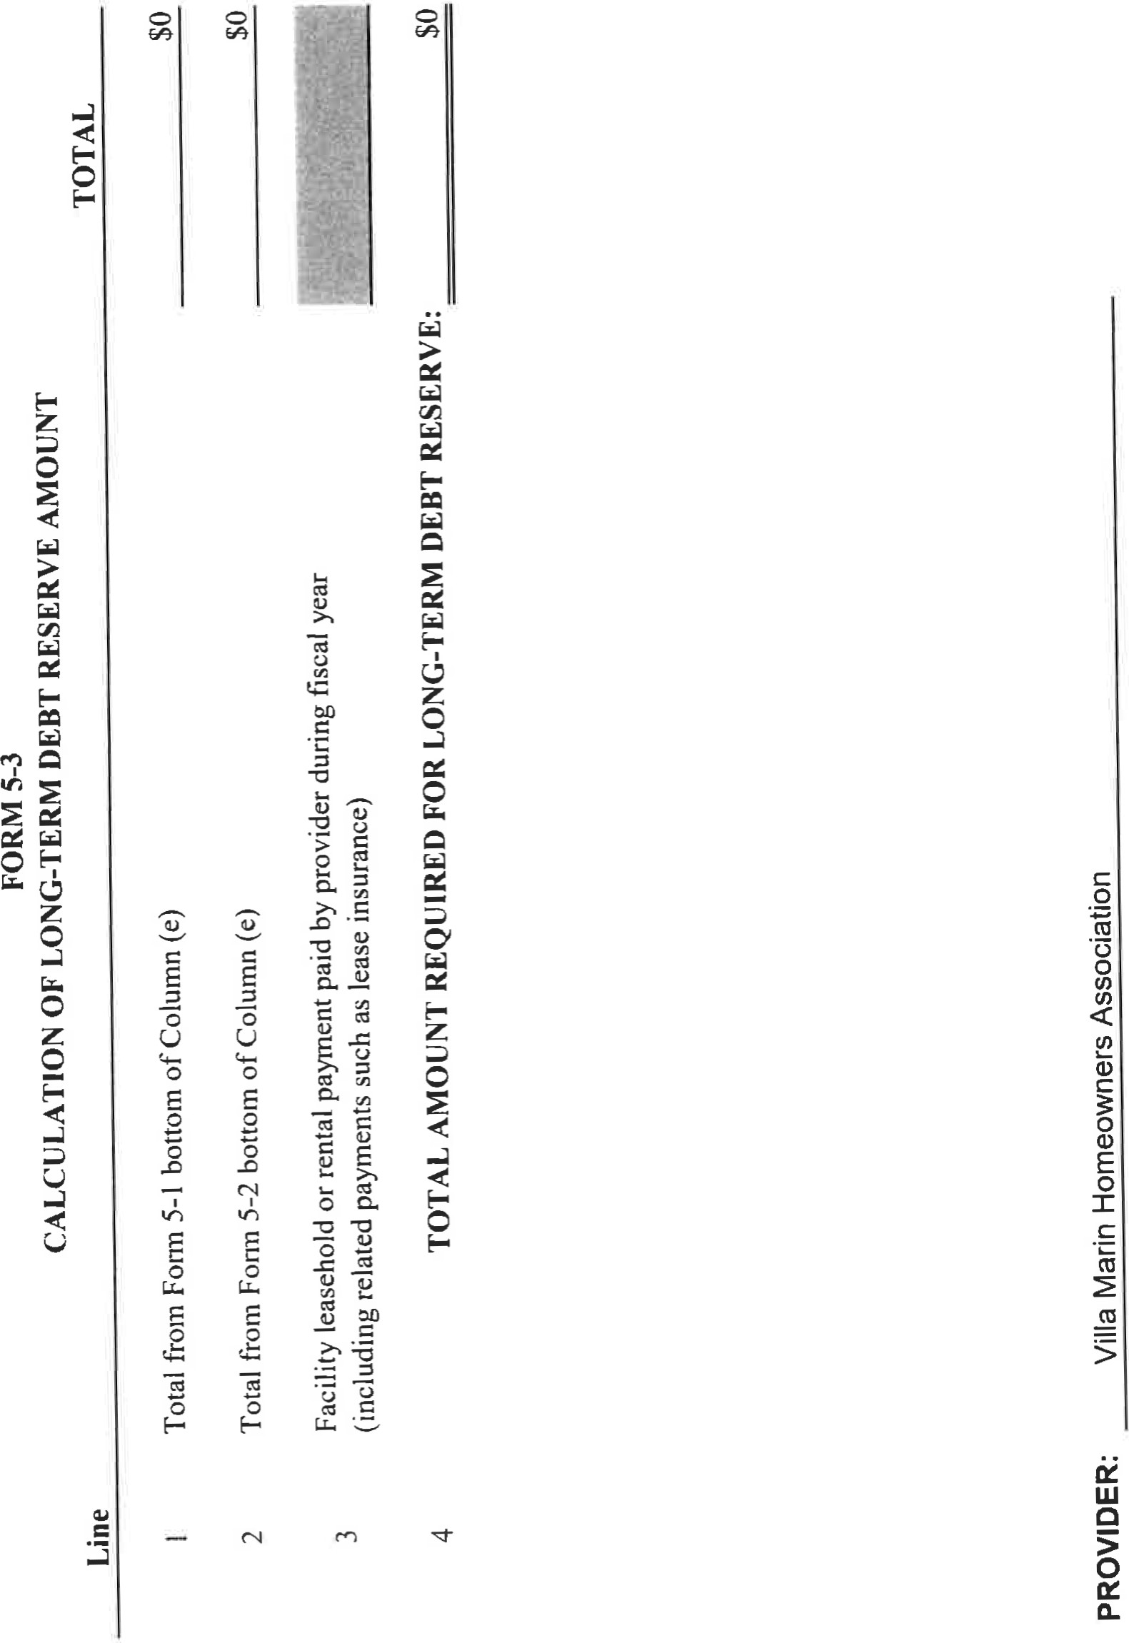
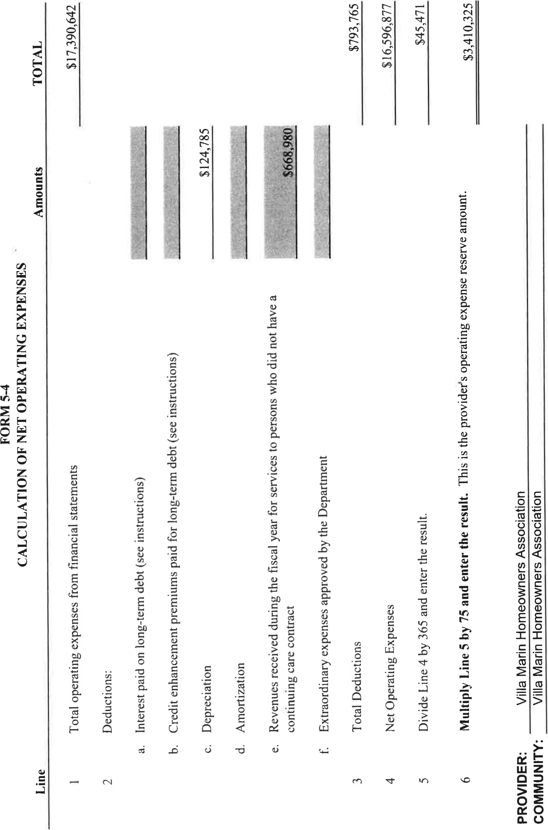
FORM S.S
ANNUAL RESERVE CERTIFICATION
Provider Name: Villa Marin Homeowners Association Fiscal Year Ended:
We have reviewed our debt service reserve and operating expense reserve requirements as of, and for the period ended and are in compliance Wilh those requirements.
Our liquid reservc requirements, computed using the audited financial statements for the fiscal year are as follows:
Amounq
(21 Operating Expense Reserve Amount | S3.4 10.325
( I J Debt Service Reserve Amount so

[31 Total Liquid Reserve Amount: S3.410.325
Amount
(mnrket value nt end of quxrter)
 | Ouatifving Asset DescriptEon | Deb Operating Resene
WI | Cash and Cash Equivalents
[51 | Investmenl Securities | $300.000
(6) | Equity Securities
 | Unused/AvaiIabIe Lines of Credit  Unused/AvailabIe Letters of Credit | $500,000
[91 | Debt Service Reserve | (nol applicable)
Qualifying assets sufficient to fulfill the above requirements are held as follows:
(101 Other:
Line of Credit in renewal
(describe qualifying asset)
Tot8t Amount of Qualifying Assets Listed for Resen•e Obligation: t I
Reserve Obligatlon Amount: 1131
Surplus/(Deficiency): 1151 SO 06) S315.046
 Date: 3/26/2026
(Authorized Representative)
Chief Executive Officer

(Title)
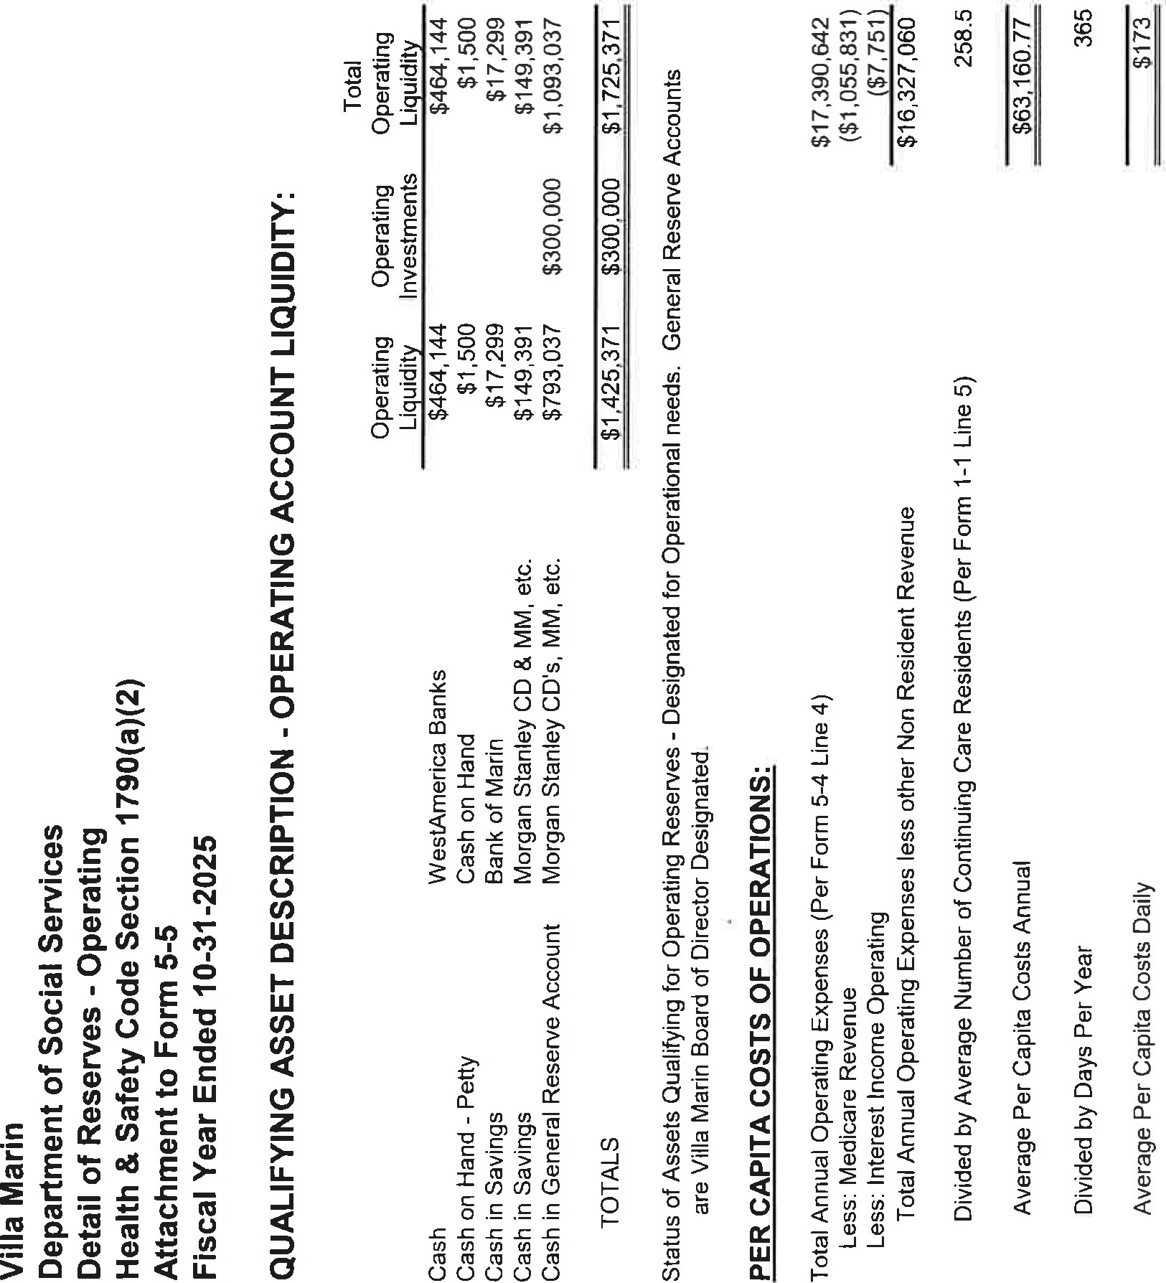
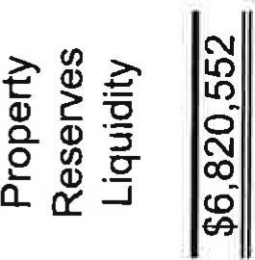
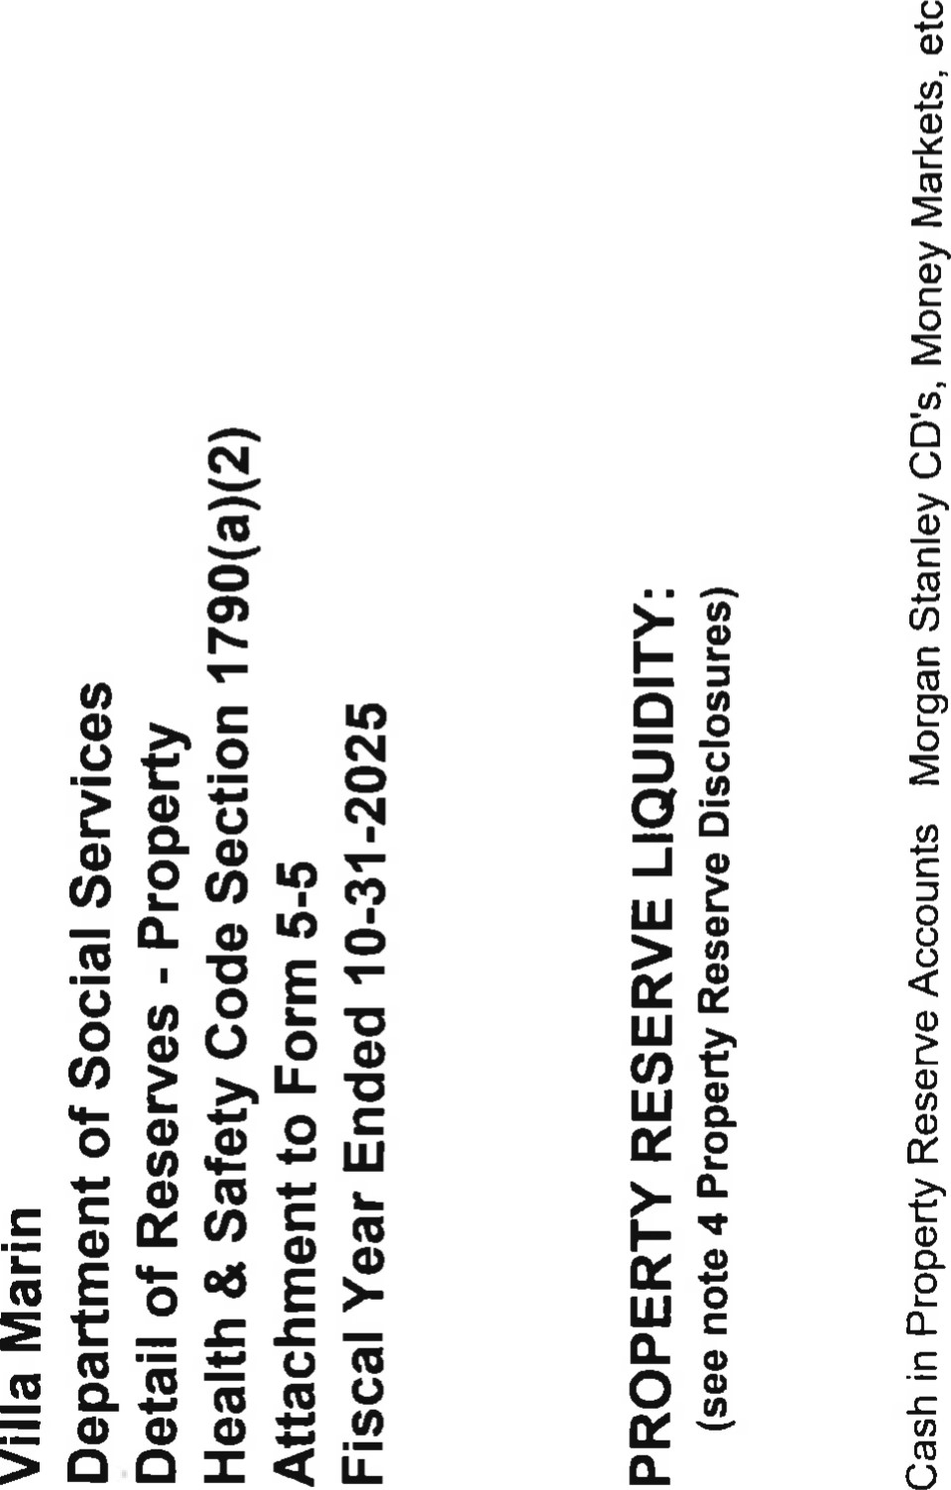

VILLA MARIN HOMEOWNERS' ASSOCIATION

NOTES TO CONTINUING CARE RESERVE REPORT SCHEDULES YEAR ENDED OCTOBER 31, 2025

NOTE 1 - THE ASSOCIATION
Villa Marin Homeowners' Association (the Association) is a common interest development located in San Rafael, California which consists of 224 residential units and certain common area proper-W. The Association was organized as a nonprofit mutual benefit corporation in September 1983 to provide for management, maintenance and architectural control of the individual units and the common area property. The Association is governed by a member-elected Board of Directors which is responsible for enforcing provisions of the governing documents, which include covenants, conditions and restrictions (CC&Rs), by laws, and rules and regulations. Major decisions, as determined by the CC&Rs, are referred to the Association's Board of Directors.
NOTE 2 - CONTINUING CARE RESERVE REPORT SCHEDULES
The California Health and Safety Code Section 1790 requires continuing care contract providers to establish and maintain statutory and refund reserves to ensure financial resources will be available to fulfill contractual obligations to residents. The continuing care reserve report schedules (Schedules), which calculate reserve requirements, are prepared in accordance with Annual Report Instructions provided by the State of California Department of Social Services. The Schedules are required to be submitted annually to the California Department of Social Services within four months of year-end.

NOTE 3 - EVIDENCE OF FIDELITY BOND
The Association is in compliance with the fidelity bond requirement through their commercial crime insurance policy purchased through a commercial insurance carrier.
See independent auditors' report.
VILLA MARIN HOMEOWNERS' ASSOCIATION

NOTES TO CONTINUING CARE RESERVE REPORT SCHEDULES YEAR ENDED OCTOBER 31, 2025 (CONTINUED)
NOTE 4 - PROPERTY RESERVE DISCLOSURES
The following disclosures are in accordance with Health and Safety Code
Section
Cash and investments in the property reserve fund at October 31, 2025 totaled $6,820,552.
The Association maintains a property reserve fund for the purposes of maintaining and/or replacing its fixed assets in compliance with the Association's non-profit mutual benefit corporation status. All property reserve amounts are designated for future projects consistent with the Association's non-profit mutual benefit corporation status. An annual study is performed projecting cash requirements and project expenditures over an ongoing 30 year basis. The Association utilizes a threshold funding method to project adequate property reserve funding be available each year over the next 30 years. The current property reserve study dated May 22, 2025 by Reserve Analysis Consulting, LLC shows adequate property reserve funding over each of the next 30 years with projected annual deposits, disbursements, rate of inflation, and return on investments to meet the threshold funding requirements of the next 30 years.
The following are the Association's major property reserve fund projects designated to be performed during the year ending October 31, 2025 as permitted by and in accordance with the Association's non-profit mutual

benefit corporation status:
Decks | $40,000
Boiler systems | 824,302
Hot water tanks | 84,872
Residential heat pumps | 206,000
Exterior structural repairs | 55,000
Air handlers | 155,952
Road repairs | 637,270
See independent auditors' report

LEVY, ERLANGER & COMPANY I-LP
100 Montgomery Street, Suite 715 San Francisco, CA 94104

INDEPENDENT AUDITOR'S REPORT
Board Of Directors
Villa Marin Homeowners' Association
San Rafael, California
We have audited, in accordance with the auditing standards generally accepted in the United States of America, the financial statements of Villa Marin Homeowners' Association (the Association) as of October 31 , 2025, and have issued our report thereon dated February 13, 2026. We have also audited the accompanying statement of cash flows-direct method of Villa Marin Homeowners' Association for the year ended October 31, 2025. This statement is the responsibility of the Association's management. Our responsibility is to express an opinion on this statement based on our audit.
We conducted our audit of the statement of cash flows-direct method in accordance with auditing standards generally accepted in the United States of America. Those standards require that we plan and perform the audit to obtain reasonable assurance about whether the statement of cash flows-direct method is free of material misstatement. An audit includes examining, on a test basis, evidence supporting the amounts and disclosures in the statement. An audit also includes assessing the accounting principles used and significant estimates made by management, as well as evaluating the overall presentation of the statement. We believe that our audit provides a reasonable basis for our opinion.
In our opinion, the statement of cash flows-direct method referred to above presents fairly, in all material respects, the cash flows of Villa Marin Homeowners' Association for the year ended October 31, 2025 in conformity with accounting principles generally accepted in the United States of America.
This report is intended solely for the information and use of the Association and for filing with the California Department of Social Services and is not intended to be and should not be used by anyone other than these specified parties.

 L-C(2
February 13, 2026
1

VILLA MARIN HOMEOWNERS' ASSOCIATION

STATEMENT OF CASH FLOWS - DIRECT METHOD YEAR ENDED OCTOBER 31, 2025
 |  | General | Property | Gifts &
 | Operating | Reserve | Replacement | Bequests | Total
OPERATING ACTIVITIES | Fund | Fund | Fund | Fund | Funds
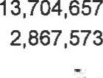
Cash Received from Residents 562255
Cash from Resident Medical Income2,867,573
Cash Received from License Fee Revenue
Interest Received for Operations | 13,776 |  |  |  | 13,776
Interest Received for General Reserve |  | (288) |  |  | (288)
Interest Received for Property Reserve |  |  | 195,557 |  | 195,557
Interest Received for Gifts & Bequests |  |  |  | 751 | 751
Cash Received from Other Revenue | 302,696 |  |  | 3,400 | 306,096
Cash Paid to suppliers and employees  Contract Liabilities Replacement Reserve |  |  | (775,908) |  | (1 8, 153,347)
Cash for (from) Interfund Loans | (1 11286) | 111286
Net cash provided by (used in) Operating Activities (500.023) 10,9984,151 8141061
INVESTING ACTIVITIES
Net (purchase) sale of certificates of deposit |  | 300,000 |  | 100,000
Net (purchase) sale of US Treasury securities |  |  | 843,072 |  | 843,072
Net (purchase) sale of fixed assets | (41,962) |  |  |  | (41 , 962)
NET INCREASE (DECREASE) IN CASH
AND CASH EQUIVALENTS  BOARD-APPROVED INTERFUND | (541,985) | 310,998 | 4,621,167 | 104151 | 4,494,331
RECLASSIFICATIONS AND TRANSFERS  CASH AND CASH EQUIVALENTS, | (19,045) | 289 |  | (2, 130) | (20,886)
BEGINNING OF YEAR |  | 481,750 |  | 47,370

(41,962)300,000 3,322,232 1 oo,ooo 3,680.270

CASH AND CASH EQUIVALENTS,
793,037
149,391
END OF YEAR 482,943
See independent auditor's report

